Khmer New Year - End Of Harvest Season

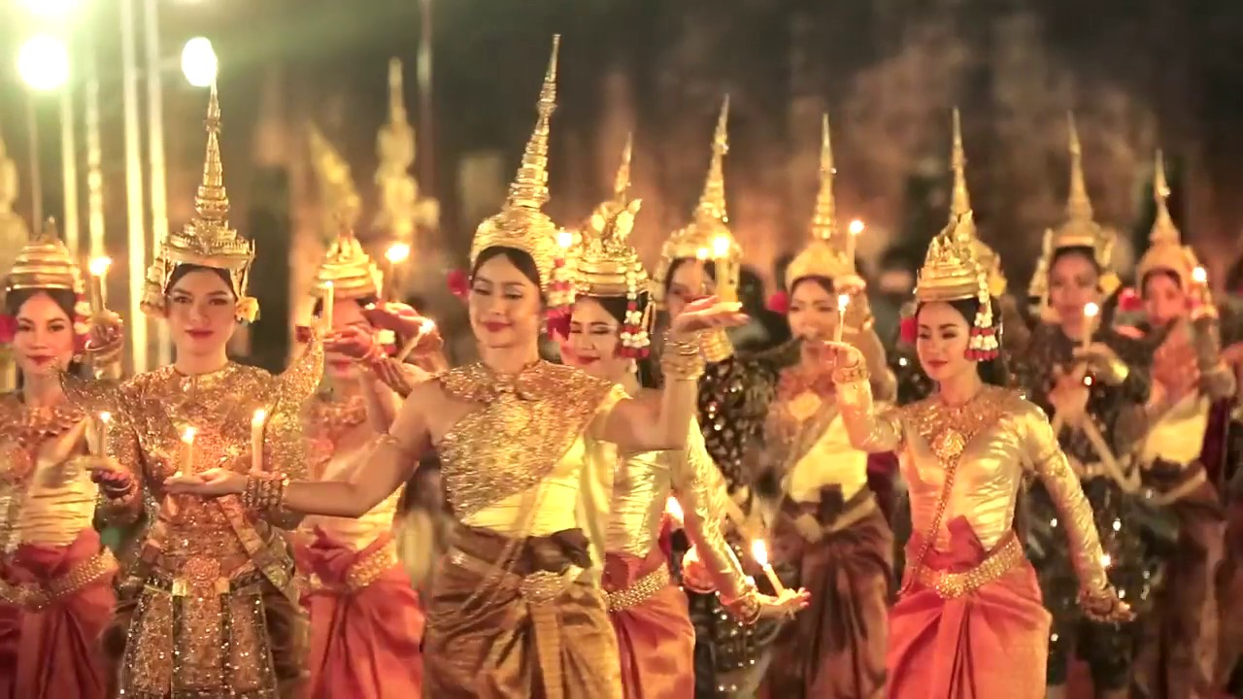

Cambodian New Year (Khmer: បុណ្យចូលឆ្នាំថ្មី) (Choul Chnam Thmey, literally "Enter New Year"), is the name of the Cambodian holiday that celebrates the traditional Lunar New Year.

The holiday lasts for three days beginning on New Year's Day, which usually falls on April 13 or 14th, which is the end of the harvesting season, when farmers enjoy the fruits of their labor before the rainy season begins. Khmers living abroad may choose to celebrate during a weekend rather than just specifically April 13 through 16th.

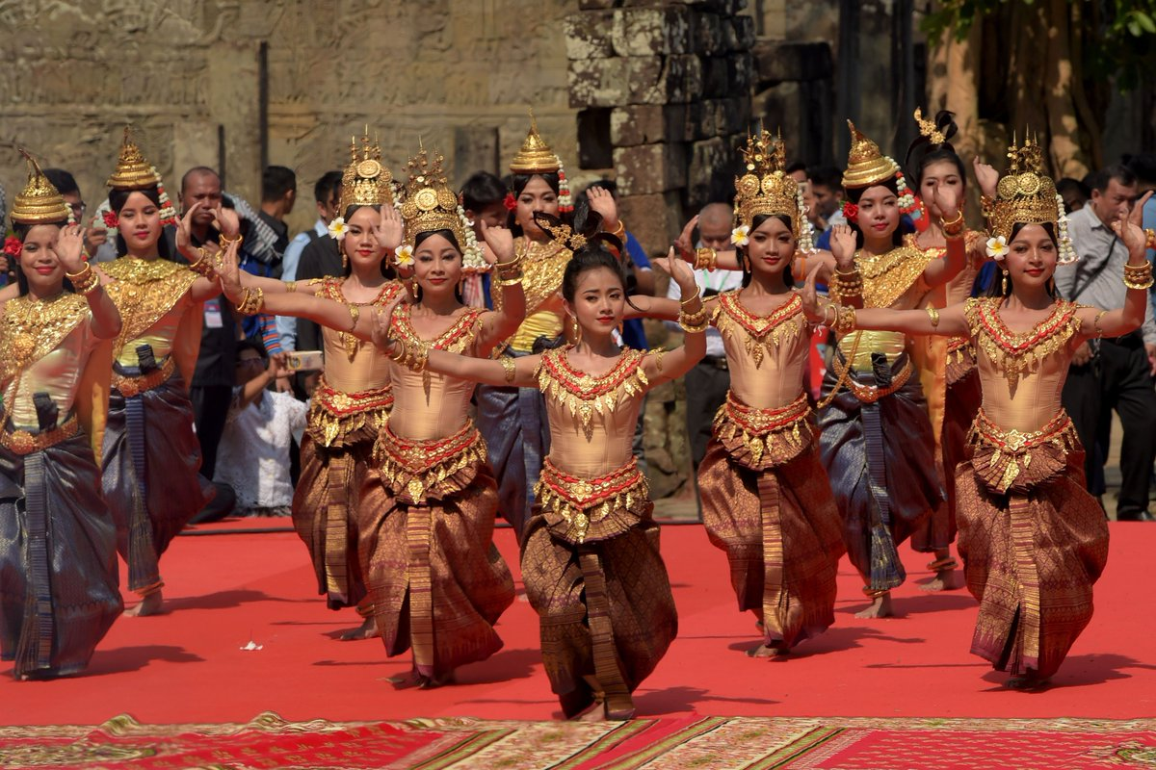

The Khmer New Year coincides with the traditional solar new year in several parts of India, Bangladesh, Nepal, Sri Lanka, Myanmar, Laos and Thailand.

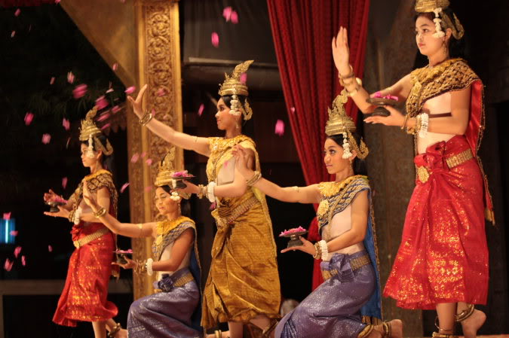

This is one of the biggest festivals in Cambodia during which Cambodians with Khmer roots stop working for a whole 3 days and return to their homes to celebrate the end of the traditional harvest season.

It is a time when the farmers, who have toiled the whole year in their farms for harvesting food, take some leisurely time off.

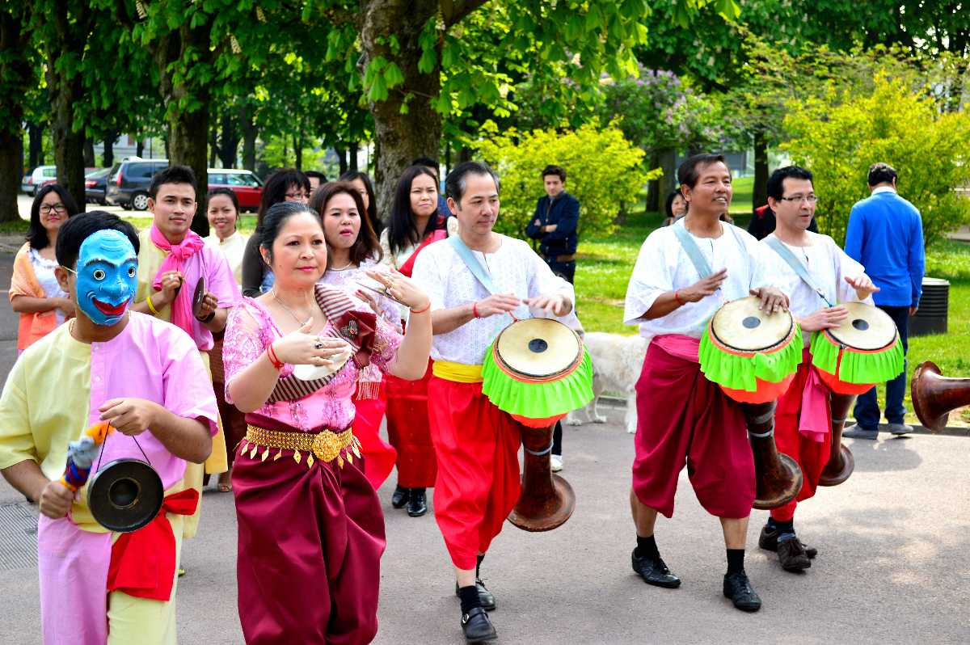

The Khmer community celebrates this day by uniting with their family members and performing many purification ceremonies, visiting their temples and having fun playing traditional games.

**When:**14th April 2020 to 16th April 2020